

# 

|  |  |
| --- | --- |
| Document Name | CRM Process Requirements –JIRA Interface |
| Version No: | 1.3 |

|  |  |  |  |  |
| --- | --- | --- | --- | --- |
| **Version No.** | **Authored / Modified by** | **Reviewed by, Date** | **Approved by, Date** | **Remark / Change History** |
| *1.0* | N. Johnson | 4/26/13 |  | Initial Draft |
| *1.1* | N. Johnson | 5/17/13 |  | Updated based on feedback from Blake Markham. |
| *1.2* | N. Johnson |  |  | Updated based on feedback from 5/17 meeting with internal tech team.   * Added SME’s * Updated assumptions * Updated flows and requirements |
| *1.3* | Vikas Basra | 04/22/14 |  | Updated the Attributes & mappings between Salesforce & Jira |

Table of Contents

1 Introduction 3

1.1 SMEs, Reviewers & Sign-offs (Who): 3

2 Project Details 3

2.1 Assumptions/Constraints (What’s Taken for Granted): 3

2.2 Risks (What to Watch): 4

2.3 Future enhancements / Exclusions / Out of Scope (What Not): 4

2.4 Primary Use Case Diagram /Functional Areas (Who Does What): 5

2.5 Process Business Diagrams (How Does It Work): 5

2.6 Salesforce Inventory (What Salesforce Objects are impacted?): 5

3 WorkFlows 6

3.1 MAIN WORKFLOW SUMMARY: 6

3.2 Process Requirements Table: 6

4 Requirements Details 7

4.1 Reporting Requirements: 7

4.2 Impacts – DT Process / Dependencies: 7

5 Reference Materials 7

5.1 Appendices: 7

5.2 External References/Websites/Other Documentation/Addendum: 9

5.3 Acronyms, Abbreviations, Definitions, and Terminology: 9

# Introduction

The goal of this document is to provide requirements which will allow the team to effectively scope the interface between Salesforce and JIRA.

## SMEs, Reviewers & Sign-offs (Who):

Subject Matter Experts (SMEs):

|  |  |  |  |
| --- | --- | --- | --- |
| Role | Name | Contact Info | Area of Expertise |
| SME 1 | Vikas Basra | 718-304-4988 | Atlassian |
| SME 2 | Blake Markham |  |  |
| SME 3 | Adeliya Geistrikh |  |  |
| SME 4 | Thomas Wirth |  |  |
| SME 5 | Keith Roller |  |  |
| SME 6 | David Davoodi |  |  |

Reviewers:

|  |  |  |  |
| --- | --- | --- | --- |
| Name | How Signature was provided | Signature | Date |
| Thomas Wirth |  |  |  |
| Rick Griskie |  |  |
| Keith Roller |  |  |
| Ellen Witrick |  |  |
| Mohamed Al-Daqa |  |  |
| Nancy Johnson |  |  |

# Project Details

## Assumptions/Constraints (What’s Taken for Granted):

Assumptions -

* The interface between JIRA and Salesforce will be two-way integration.
* This interface will support all WorkItem cases initiated from the Level 3 TPO’s only.
* A Triage meeting will be held by Level 3 (including Product and Tech team members) to discuss all items prior to escalating items to JIRA.
* There is no SAP Tech involvement required for this project as a JIRA connector will be purchased to interface between JIRA and Salesforce.

Constraints –

## Risks (What to Watch):

|  |  |  |  |  |  |  |  |  |
| --- | --- | --- | --- | --- | --- | --- | --- | --- |
| **#** | **Date Opened / By Whom** | **Title** | **Description** | **Probability** | **Priority** | **Treatment / Action** | **Owner** | **Contingency Plan** |
| 1 |  |  |  |  |  |  |  |  |
| 2 |  |  |  |  |  |  |  |  |
| 3 |  |  |  |  |  |  |  |  |
| 4 |  |  |  |  |  |  |  |  |
| 5 |  |  |  |  |  |  |  |  |

## Future enhancements / Exclusions / Out of Scope (What Not):

|  |  |  |  |  |  |
| --- | --- | --- | --- | --- | --- |
| **e** | | **Date** | **Author** | **Excluded Idea** | **Out of Scope Reason** |
| 1 | |  |  |  |  |
| 2 |  |  |  |  |

## Primary Use Case Diagram /Functional Areas (Who Does What):



## Process Business Diagrams (How Does It Work):

Business Diagram

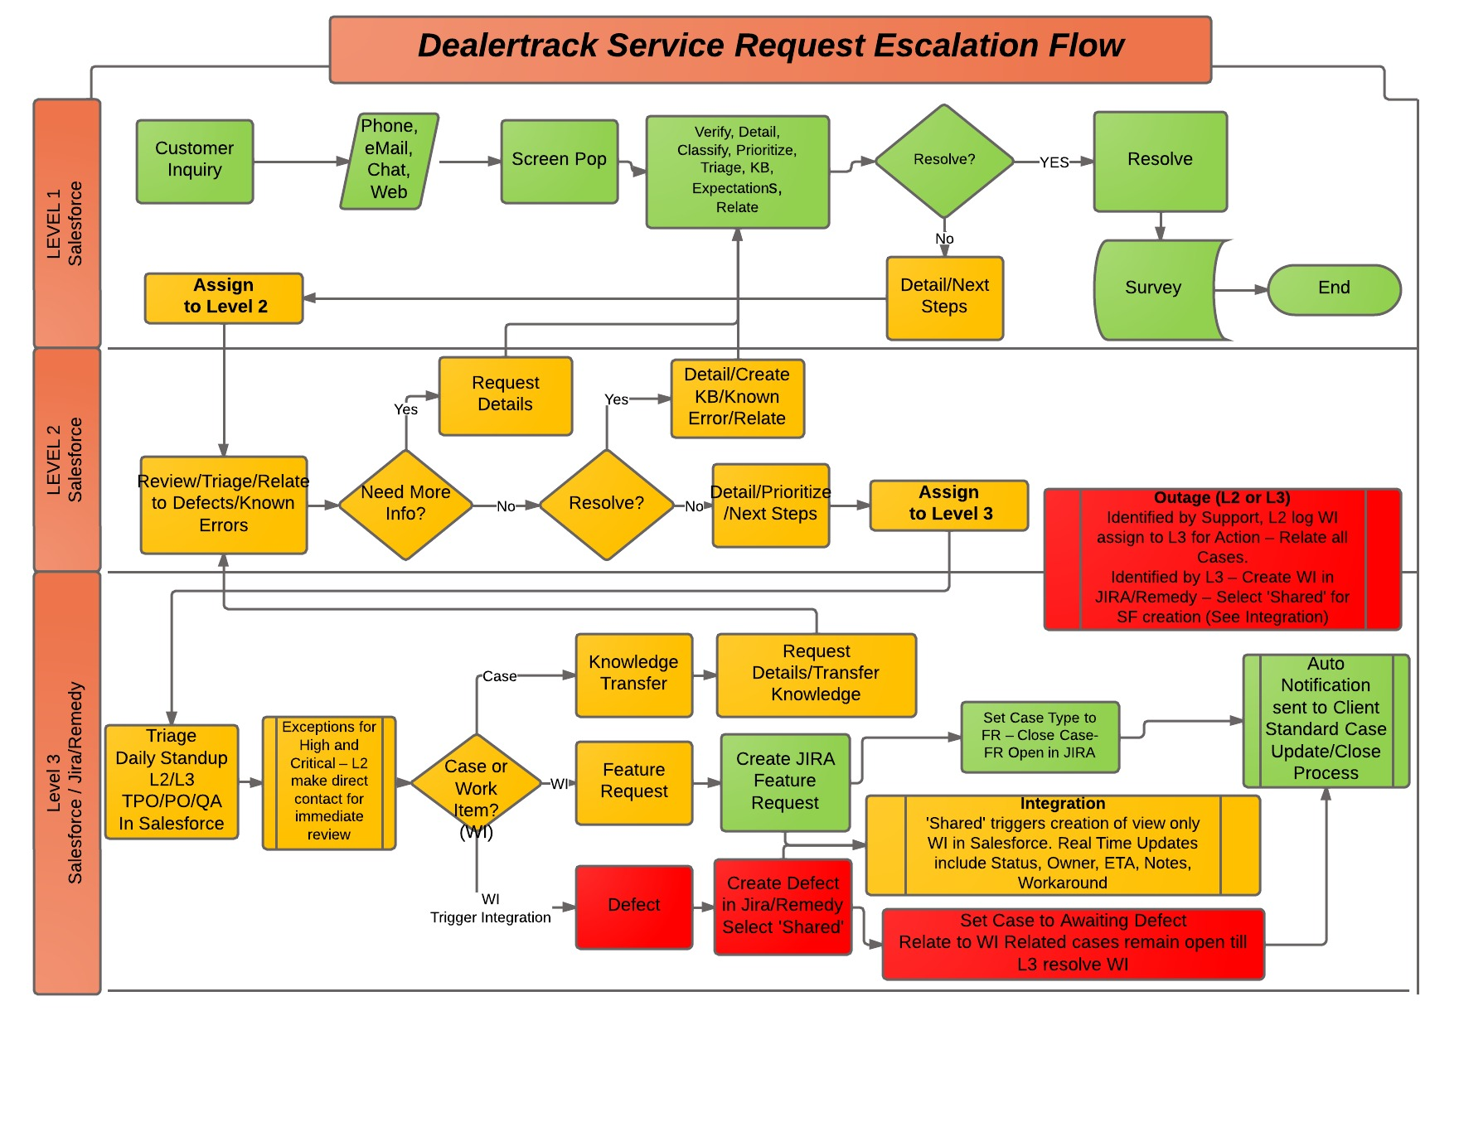

## Salesforce Inventory (What Salesforce Objects are impacted?):

* Case

# WorkFlows

## MAIN WORKFLOW SUMMARY:

Casual Summary: The Agent escalates the case to Level 3/TPO. The Level 3/TPO team will review the escalated cases from within Salesforce and determine whether they need more information, it’s a feature request/enhancement or it’s a defect. If it is determined by Level 3 that it is a Feature Request/Enhancement or Defect, a WorkItem case will be created for the applicable Solution team. The system will transfer the WorkItem case information to JIRA to create a ticket. JIRA will send the applicable information back to Salesforce to update the WorkItem Case and associate the original case with the WorkItem Case. The Level 3/TPO team will link the defect/enhancement to a Project/Release and implement the enhancement/defect. The system will transfer the any information updated in JIRA to Salesforce to update the WorkItem Case. Once the Project/Release is completed, the system will trigger an updated back to Salesforce to update the WorkItem Case and all of the associated cases with the appropriate “Resolved” status.

## Process Requirements Table:

| **Req ID** | **Requestor** | | **Requirement Name** | **The Requirement (Description)** | **Priority**  **- LMH** |
| --- | --- | --- | --- | --- | --- |
|  |  | **Create JIRA Ticket** | | | |
| JIRA-01 | N. Johnson | CJ – CRM | | Level 3 creates a WorkItem Case against the appropriate Solutions team by cloning the DT Case. The creation of the Work Item case will trigger the JIRA integration. |  |
| JIRA-02 | N. Johnson | CJ – PI | | The system will pass the “create” fields via a web service to JIRA:   * See JIRA Field Appendix |  |
| JIRA-03 | N. Johnson | CJ- JIRA | | The system will create a JIRA Ticket and escalate accordingly. |  |
| JIRA-04 | N. Johnson | CJ – PI | | The system will pass the JIRA ID assigned to the Ticket back to Salesforce |  |
| JIRA-05 | N. Johnson | CJ-CRM | | The system will update the appropriate WorkItem case with the JIRA Ticket ID.   * See JIRA Field Appendix |  |
| JIRA-06 | N. Johnson | CJ-CRM | | The system will associate the originating case to the “WorkItem” case just created and change the originating Case status to “Pending Work Item” |  |
|  |  | **Implement JIRA Release/Project** | | | |
| JIRA-07 | N. Johnson | IJ – JIRA | | The user sets the JIRA Release/Project status to “Complete” in JIRA. |  |
| JIRA- 08 | N. Johnson | IJ – JIRA | | The system will automatically update all associated Enhancements/Defects as “Released”. |  |
| JIRA-09 | N. Johnson | IJ | | The system will pass the following fields via web service to the CRM:   * See JIRA Field Appendix |  |
| JIRA-10 | N. Johnson | IJ – CRM | | The system will update the appropriate CRM WorkItem Case(s) to the “Resolved Pending Confirmation” status. |  |
| JIRA-11 | N. Johnson | IJ – CRM | | The system will update the associated cases to the “Resolved Pending Confirmation” status. |  |
| JIRA-12 | N. Johnson | IJ – CRM | | Resolved Pending Confirmation will trigger a ‘Call’ Task and Auto Send 3 email attempts 1 business day apart before Auto Closing to “Resolved Attempted Confirmation” |  |
|  |  | **Update CRM WorkItem Case** | | | |
| JIRA-13 | N. Johnson | UW – CRM | | The agent updates the CRM WorkItem Case with additional information/attachments. |  |
| JIRA-14 | N. Johnson | UW | | The system determines if one of the “create or update” fields has changed and if so, passes the “create or update” fields via a web service to JIRA:   * See JIRA Field Appendix |  |
| JIRA-15 | N. Johnson | UW –JIRA | | The system updates the appropriate JIRA ticket and sets the appropriate status. |  |
| **Update JIRA Ticket** | | | | | |
| JIRA-16 | N. Johnson | UJ – JIRA | | The user updates the JIRA Ticket (request more information, update ticket type or links the ticket to a Project/Release) |  |
| JIRA-17 | N. Johnson | UJ | | The system determines if one of the “update” fields has changed and if so, passes the “update” fields via web service to the CRM:   * See JIRA Field Appendix |  |
| JIRA-18 | N. Johnson | UJ – CRM | | The system updates the CRM WorkItem Case. |  |
| **Create CRM WorkItem** | | | | | |
| JIRA-19 | N. Johnson | CW – JIRA | | The TPO creates a new Ticket in JIRA. |  |
| JIRA-20 | N. Johnson | CW – PI | | The system passes the appropriate fields to create a “Salesforce WorkItem Case” based on the JIRA Ticket data. |  |
| JIRA-21 | N. Johnson | CW – CRM | | The system will create a Salesforce WorkItem with a status of “Working”.   * See JIRA Field Appendix |  |
| JIRA-22 | N. Johnson | CW – PI | | The system will pass the CRM WorkItem ID assigned back to JIRA. |  |
| JIRA-23 | N. Johnson | CW- JIRA | | The system will update the Ticket with the CRM WorkItem ID. |  |

# **Requirements Details**

## **Reporting Requirements:**

* N/A

## **Impacts – DT Process / Dependencies:**

* N/A

# Reference Materials

## Appendices:

JIRA Field Appendix

The following fields will be configured on the “Work Item” case under a separate panel called as “Jira Issue Updates”

|  |  |  |  |
| --- | --- | --- | --- |
| S. No | Label Name  (Salesforce) | Type | Jira Mappings |
| 1 | Solution | Picklist | Linked to Project Category |
| 2 | Product | Picklist | Product |
| 3 | Category | Picklist | Category (Available under Salesforce Tab) on every Issue |
| 4 | Sub Category | Picklist | Component |
| 5 | Jira Project | Jira Project | Project name in Jira |
| 6 | Jira Issue Key | Text(10) | Issue Key in Jira |
| 7 | Jira Assignee | Text(50) | Assignee |
| 8 | Performance Testing | Picklist | Performance Testing |
| 9 | Jira Severity | Picklist | Severity |
| 10 | Defect Cause | Picklist | Defect Cause |
| 11 | Jira Release | Lookup(Jira Project) | Fix Version |
| 13 | Jira Status | Text (50) | Status  (Reference Model Workflow Status) |
| 14 | Jira Priority | Picklist | Priority |
| 15 | Target Release Date | Date | Due Date |
| 16 | Environment | Picklist | DT Environment |
| 17 | Test Phase | Picklist | Test Phase |
| 18 | Comments | Text Field | Comments |

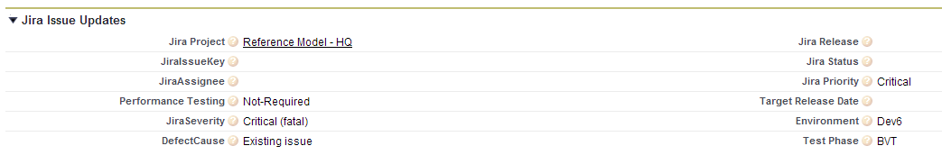

## External References/Websites/Other Documentation/Addendum:

## Acronyms, Abbreviations, Definitions, and Terminology:

HML/LMH – High, Mid, Low for priority, probability, complexity, etc